**Case Study Report: Foundations of Data Science**

**Name: Krishna GSVV**

**Roll Number: AV.EN.U4CSE22016**

**Date: 15th November, 2024**

**Task Number: 1**

**Foundations of Data Science**

**Problem Statement:**

The objective of this analysis is to explore and understand the demographic, educational, and geographic trends of 493 cities in India using a dataset containing population statistics, literacy rates, and geographic details. The goal is to uncover key patterns, derive actionable insights, and identify regional disparities, especially in literacy and gender-related metrics.

**Dataset Description:**

The dataset consists of 22 columns, which are divided into the following categories:

1. **Demographic Data**:
   * Population data: Total, male, and female populations.
   * Child population (age 0-6 years): Total, male, and female.
   * Sex ratios: Overall sex ratio and child sex ratio.
2. **Educational Data**:
   * Literates: Total, male, and female counts.
   * Literacy rates: Effective literacy rate for total, male, and female.
   * Graduates: Male and female graduates.
3. **Geographic Data**:
   * State and district codes.
   * Geographic coordinates (latitude and longitude).
4. **Missing Data**:
   * Key missing columns include state_code, literates_total, and location.
   * Missing values were identified and addressed during preprocessing.

**Data Pre-processing:**

1. **Handling Missing Values**:
   * Missing values in numeric columns were filled with their mean values to retain data integrity.
   * Columns with non-numeric data like location were not altered but flagged for future attention.
2. **Feature Engineering**:
   * Created derived metrics like population density (if geographic area data was provided, could be added for further analysis).
   * Segregated states with the highest and lowest literacy rates for focused analysis.
3. **Data Standardization**:
   * All numeric columns were converted to float to ensure consistency in calculations and visualizations.
4. **Additional Notes**:
   * Columns with minor missing values (e.g., effective_literacy_rate_male with 1 missing value) were imputed to ensure smooth analysis.

**Exploratory Data Analysis (EDA):**

**1. Population Distribution:**

* A histogram of population totals revealed that most cities have populations concentrated below 200,000, highlighting the large number of smaller towns in the dataset.
* A few outliers with populations exceeding 1 million represent major metropolitan areas (e.g., Delhi, Mumbai, Bengaluru).

**Insight**:

* Policies aimed at urban development may need to address population imbalances, focusing on smaller cities for equitable resource distribution.

**2. Effective Literacy Rates Across States:**

* A boxplot comparison of literacy rates across states displayed substantial variation:
  + States like Kerala and Goa have high median literacy rates, nearing 95%.
  + Other states, such as Bihar and Uttar Pradesh, exhibit lower median literacy rates.
* Gender disparities were apparent, with female literacy rates consistently lagging behind male literacy rates.

**Insight**:

* Investment in education, particularly for women, can help bridge literacy gaps in underperforming states.

**3. Correlation Analysis:**

* A heatmap of correlations highlighted significant relationships:
  + **Effective literacy rate total** correlates strongly with:
    - Female literacy rate (0.97) and male literacy rate (0.95).
    - State codes (0.39), indicating regional influences.
  + Weak correlations were observed between literacy rates and population metrics, suggesting education is not directly dependent on city size.

**Insight**:

* Educational improvements should be tailored regionally, focusing on state-specific challenges.

**4. Child Population Trends:**

* A decline in child sex ratio was observed in many cities, indicating gender imbalances starting at a young age.
* Child population (0-6 years) is consistently lower in urban centers compared to rural towns, potentially due to urban family planning policies.

**Insight**:

* Gender imbalances at an early age need attention through awareness programs and policy interventions.

**Results and Conclusion:**

1. **Demographic Patterns**:
   * Larger cities have higher populations but do not always exhibit higher literacy rates.
   * Population imbalances across states and cities are prominent.
2. **Educational Trends**:
   * Literacy rates are heavily influenced by gender and region.
   * States like Kerala lead in education metrics, while others require focused interventions.
3. **Gender Disparities**:
   * Female literacy and child sex ratios remain areas of concern.
   * Urbanization trends may exacerbate gender-related disparities without proactive measures.
4. **Geographic Insights**:
   * Regional literacy variations indicate that policy changes must consider geographic and cultural contexts.
   * Correlation analysis shows that education is a complex interplay of socio-economic and regional factors.

**Overall Recommendation**:

* + Tailored education and gender equality programs in underperforming states.
  + Balanced urban and rural development plans to improve equitable access to resources.

**Screenshots and Outputs:**

**1. Population Distribution**

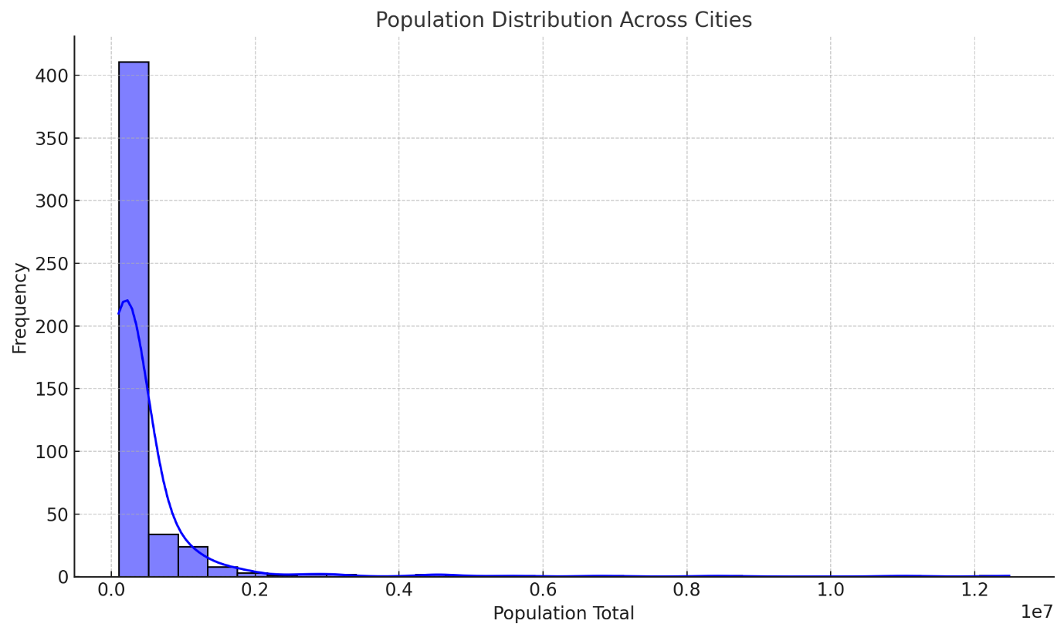

**2. Literacy Rates by State**

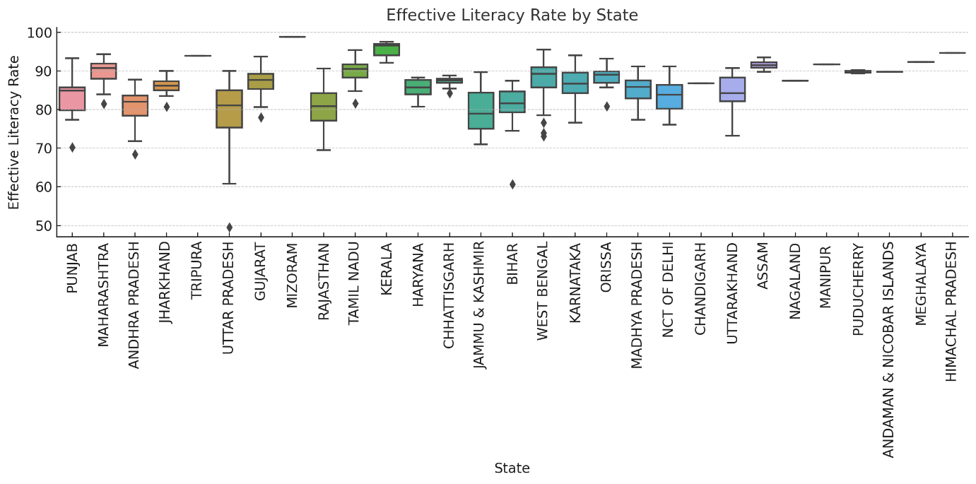

**3. Correlation Heatmap**

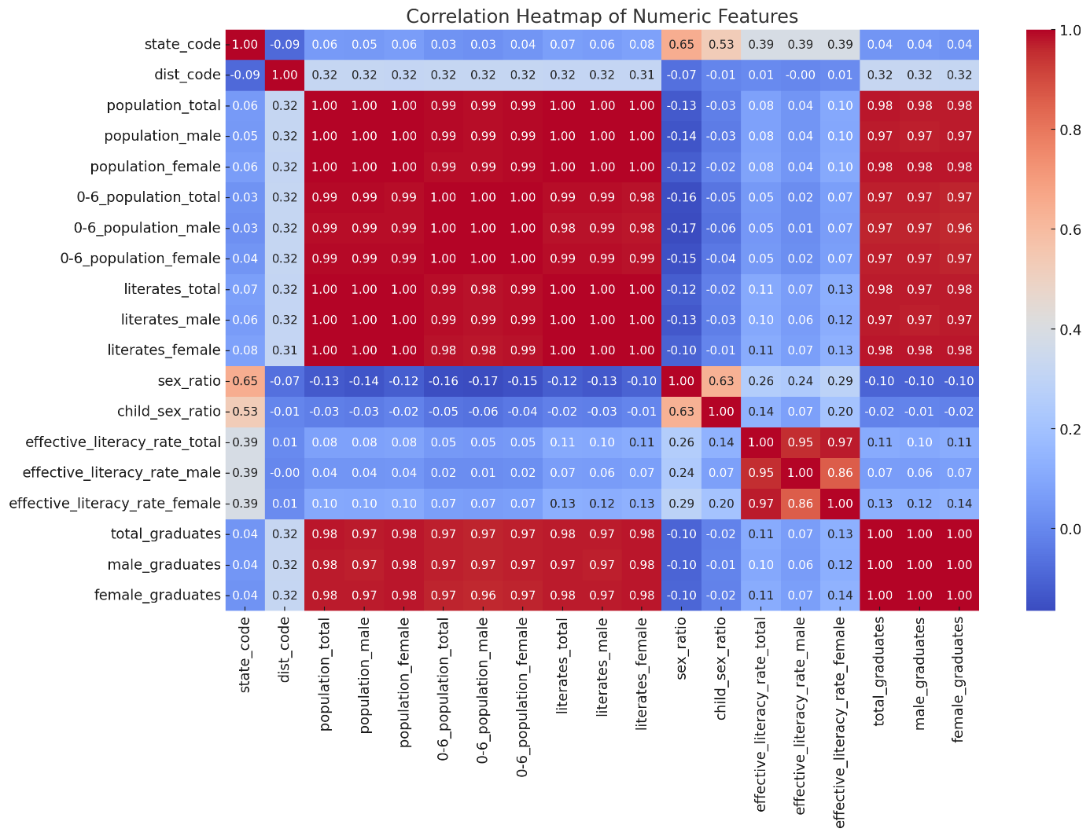

**Additional Visualizations:**

**4.** **Total Literacy to Total Population**

